**Deploy Tomcat on Minikube from GitHub**

This document will help and do the deployment on k8 (local minikube) from github

**Prerequisites**

1. Installed:
   * **Minikube**
   * **kubectl**
   * **Git**

Create GitHub Repository

<https://github.com/manoharjhakumar/tomcat-k8s-deploy>

clone the repo to your local. And add the 3 file like below( all code you can find in my repo)

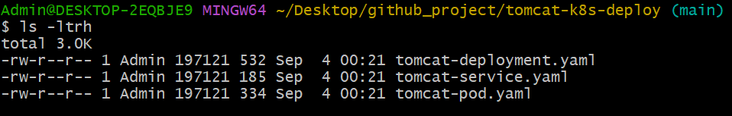

If you want to do deploymet for gitlab action then also create a deploy.yaml like below

Mkdir –p .github/workflows/

Go to dir .github/workflows/ then create the file deploy.yaml

name: Deploy to Minikube

on:

push:

branches: [ "main" ]

jobs:

deploy:

runs-on: ubuntu-latest

steps:

- name: Checkout repo

uses: actions/checkout@v3

- name: Setup Kubectl

uses: azure/setup-kubectl@v3

with:

version: 'v1.27.0'

- name: Apply Kubernetes Manifests

run: |

kubectl apply -f k8s/tomcat-deployment.yaml

kubectl apply -f k8s/tomcat-service.yaml

**Note: if you want to do GitHub runner then local Minikube cluster need to connect kubeconfig secret**

**IF not fallow below:**

**Deploy to Minikube**

**kubectl apply -f tomcat-deployment.yaml**

**kubectl apply -f tomcat-service.yaml**

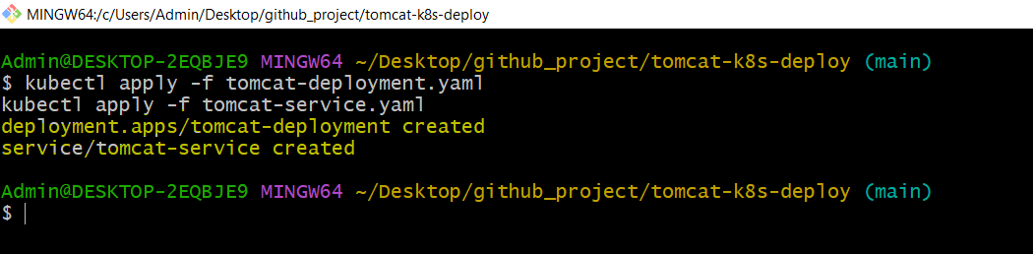

Check resources:

**kubectl get deployments**

**kubectl get pods**

**kubectl get svc**

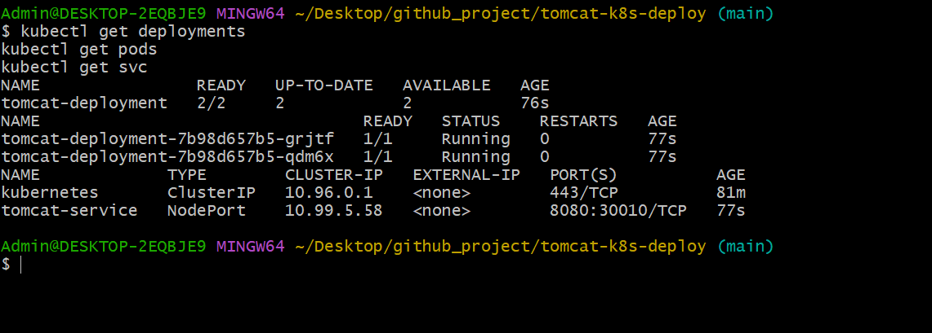

Access Tomcat

**minikube ip**

